8.3 Subqueries and Common Table Expressions

#2 Using the ProductInventory table, display the ProductID, LocationID, Shelf, Bin, Quantity columns.  
But only display the rows that have their location in the exact same LocationID of the Production.Location place with the name of 'Paint Shop'.

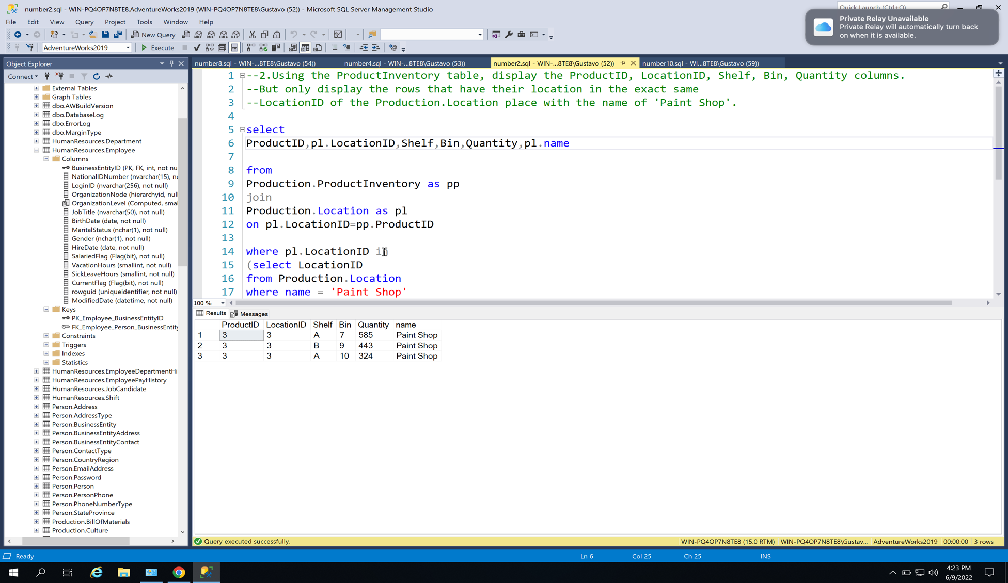

#4 Using the Product table, display the product_id, name, standardcost, listprice of all products that have a standardcost  
Greater Than the average standardcost.

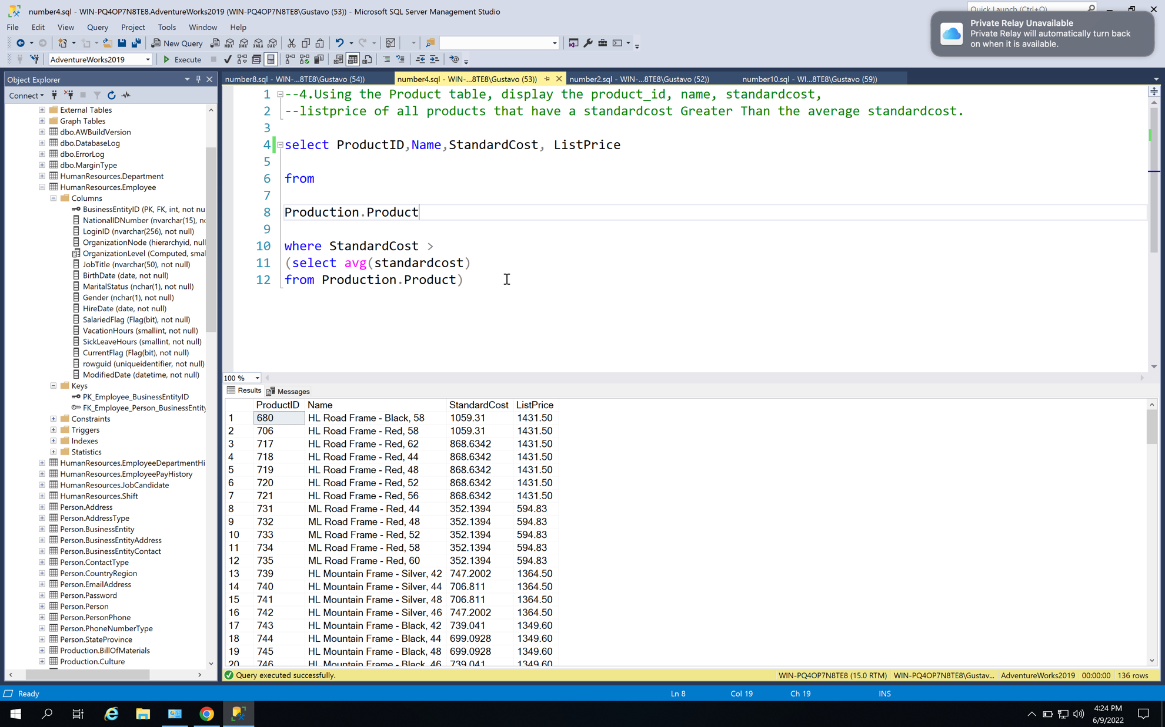

#8 Using the StateProvince table, display the (StateProvinceID, CountryRegionCode, Name, TerritoryID)  
of all the state provinces that are in the same TerritoryID of the row that has a name = 'Saxony'.

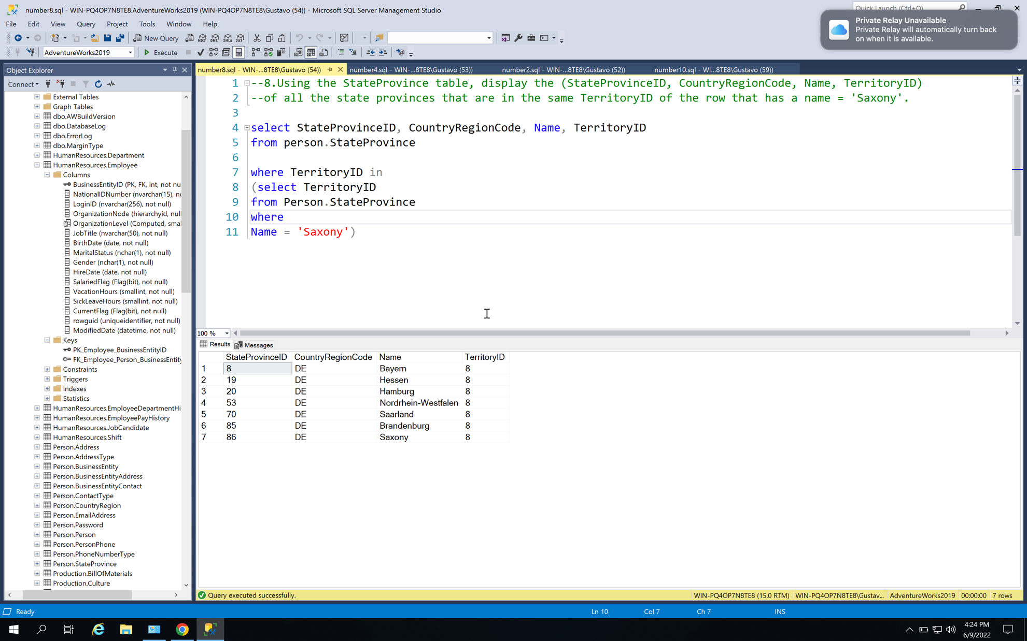

#10 Using the PERSON table, display the first and last names of all employees that have more than average vacation time.  
Hint: Use a subquery to find their businessentitiyid in the EMPLOYEE table.  
Hint Hint: Use a sub-subquery to find the average vacation hours in the EMPLOYEE table.

